Investigating the effectiveness of the broad-spectrum antimicrobial agent P-Ag-MSN
The effect of different concentrations (µg/mL) of P-Ag-MSN on the growth of four microbes.
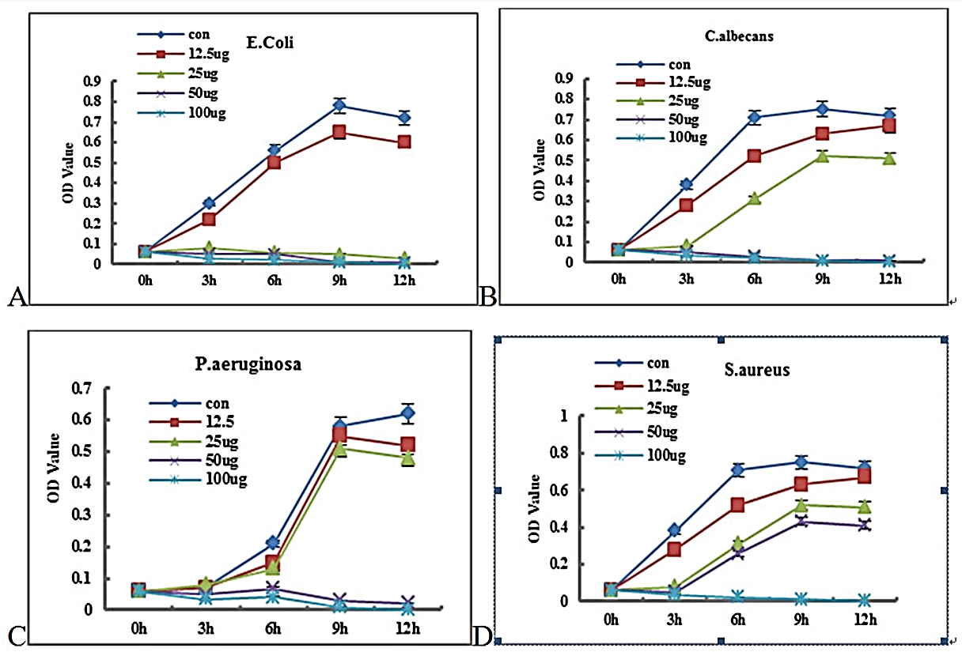
Note – this data is a little unusual as the variations of the independent variable (concentration of P-Ag-MSN) is not on the x axis. This happens because the effect of the independent variable is measured over time, so the independent variable is shown by the different lines on the graph.
Figure 1A, 1B, 1C, and 1D. Growth curves of four micro-organisms in various concentrations of P-Ag-MSN (platelet derived growth factor incorporated into silver mesopore nanoparticles). The bacteria were Escherichia coli; Candida albicans; Pseudomonas aeruginosa; and Staphylococcus aureus. Growth was measured by the OD (Optical Density) of the microbe solution.
The data above was obtained from a study investigating usefulness of P-Ag-MSN as a biomedical scaffolding material (see reference below). The specific idea behind the research was to investigate if P-Ag-MSN would be useful as a scaffold (support structure) to grow human tissue in a lab setting. One of the three factors looked at by the research was the antimicrobial activity of P-Ag-MSN. Antimicrobial activity is simply measuring how well something stops the growth of a range of microscopic organisms. The data above measures the effectiveness of P-Ag-MSN at stopping the growth of 3 bacteria (Escherichia coli; Pseudomonas aeruginosa; and Staphylococcus aureus), and one common fungus (Candida albicans). The concentrations mentioned above are in micrograms (µg) of the growth factor per millilitre of the silver mesopore nanoparticles.
Reference
Ma C, Wei Q, Cao B, Cheng X, Tian J, Pu H, et al. (2017) A multifunctional bioactive material that stimulates osteogenesis and promotes the vascularization bone marrow stem cells and their resistance to bacterial infection. PLoS ONE 12(3): e0172499. doi:10.1371/journal.pone.0172499
Identifying Trends and Relationships
A concentration of 100 µg/mL of P-Ag-MSN was the only concentration which stopped the growth of all four microbes in this investigation. However, the effect of P-Ag-MSN on growth was not consistent for all four microbes. P-Ag-MSN was most effective at reducing growth of E. coli, followed by C. albicans, P. aeruginosa, and was least effective for S. aureus. Concentrations of 25 µg/mL and higher stopped growth in E. coli, concentrations of 50 µg/mL and higher stopped growth in C. albicans, and P. aeruginosa, and only a concentration of 100 µg/mL was least effective at stopping growth for S. aureus.  As the concentration of P-Ag-MSN increased, the growth of E. coli decreased. At concentrations of 25, 50, and 100 µg/mL, there was no growth in the E. Coli samples. At these concentrations the OD actually decreased slightly over time to approximately zero. At a concentration of 12.5 µg/mL of P-Ag-MSN, the growth of E. coli was similar, but slightly less than the control sample which had no P-Ag-MSN. The maximum OD reached by the 12.5 µg/mL was 0.65 after nine hours, compared to the control sample which reached an OD of 0.8.  As the concentration of P-Ag-MSN increased, the growth of C. albicans decreased. At concentrations of 50 and 100 µg/mL, there was no growth in the E. Coli samples, and the OD actually decreased slightly over time to approximately zero after twelve hours. At a concentration of 12.5 µg/mL the pattern of growth was similar to, but slightly less than the control. At this concentration, the OD after twelve hours was 0.65, which was only slightly less than the control value of 0.7. At a concentration of 25 µg/mL the growth of C. albicans was also similar to the control, but significant less growth than it. At this concentration, the OD after twelve hours was 0.5, compared to the control value of 0.7.  Try writing the other two paragraphs. | Most important trend is to overall trend in the four graphs together, so this is the first trend identified  First simple sentence statement of trend.  Description of trend in more detail.  Data to support the identification  The rest of the trends are specific to each graph and equally as important – so they are listed in order of the graphs  First is a simple statement of the trend in graph A.  Description of the trend in more detail – supported by data  More description of the trend – also with data to support it  First is a simple statement of the trend in graph A.  Description of the trend in more detail – supported by data  More description of the trend – also with data to support it  More description of the trend – also with data to support it

